 | 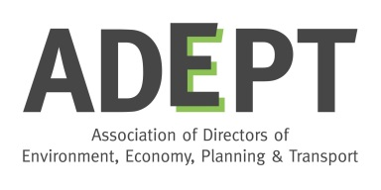
The Rt Hon Robert Jenrick MP  Exchequer Secretary to the Treasury  By email | Cllr Martin Tett  Chair  Environment, Economy, Housing & Transport Board  Local Government Association  Neil Gibson  ADEPT President  & Executive Director  Transport Economy Environment  Buckinghamshire County Council

3rd July 2018

Dear Mr Jenrick

On behalf of the Local Government Association and the Association of Directors of Environment, Economy, Planning & Transport, we write to outline our concerns in relation to the suggestion of an incineration tax, and to outline that such a tax would have major implications for local authorities and their communities, but above all, would be ineffective and is unnecessary.

Following the recent call for evidence on fiscal measures to increase recycling, you were reported as saying that the Treasury is considering instituting an incineration tax to encourage the recycling of plastic waste. We appreciate that any such proposal would be subject to formal discussion and consultation, but believe that the case against introducing an incineration tax is compelling and should render the suggestion obsolete.

We would like to emphasise that both our organisations are supportive of the Government's ambitions for waste and the environment, and are committed to working with DEFRA to deliver them. We recognise the need for us all to continue to improve recycling and reduce the amount of waste that is consigned to landfill, especially plastic waste. However, a tax on incineration of waste will introduce new burdens and have serious implications for local authorities and their communities, and is unlikely to have any significant impacts on delivery of the objectives of the Government’s forthcoming Resources & Waste Strategy.

It may be tempting to see an incineration tax as analogous to the landfill tax, which has undoubtedly been very influential in diverting waste away from landfill to other outlets including recycling and incineration. Landfill as a waste disposal option is the least desirable option therefore a tax on landfill could only result in a better outcome. However, an incineration tax would compromise the success of the landfill tax, and could create the perverse outcome of incentivising landfill over incineration. Incineration is a reliable and cost effective waste management option. A tax on its use will prejudice its use as a legitimate waste treatment option, and will not be as effective in driving positive alternative behaviours as the landfill tax.

The landfill tax achieved its objective by increasing the costs of landfill to a point where other options became economically viable. The investment for these alternative options came largely through private finance, and through commitments made by local authorities to long term waste supply contracts. Local authorities were encouraged to invest in long term treatment contracts with direct government support, including through PFI funding. Incineration featured in many of the solutions delivered through this process. These arrangements typically used Government sponsored standard form contracts which, in most cases, would see the introduction of any incineration tax as a qualifying change in law. This would mean costs passing directly through to the local authority as the client. It is perverse and unfair that local authorities should then be punished by the imposition of a tax on the use of infrastructure delivered with Government support. Local government cannot afford such a burden.

Even if local authorities were protected from the direct costs of an incineration tax, most long term contracts contain minimum tonnage guarantees and protection for the operators from changes in calorific value of waste. This means that the intended implications of an incineration tax would still hurt local authorities.

The best mechanism to achieve our shared objectives of increasing recycling is through extended producer responsibility and the reform of the packaging regulations. It is the producers, manufacturers and retailers of packaging that should incur the costs of compliance with the objectives of a circular economy, not local authorities. A tax on incineration will ultimately be unnecessary if the Government's stated intentions around the circular economy including commitments to deposit return schemes and bans on single use plastics are delivered.

We are united in our conclusion that an incineration tax would be very bad news for local authorities; ultimately, it also would be counterproductive. The cost of an incineration tax would fall largely to local authorities at a time when we are facing unprecedented financial pressures and no palatable choices for further savings. Indeed, it is hard to conceive how we would deliver a message to residents that would explain the inevitable reductions to core services resulting from having to pay the costs of an incineration tax. We also consider that a tax on the use of incineration indicates a lack of confidence by central Government in the delivery of its stated objectives for waste and resources through other means. We remain committed to working with Government to help find more acceptable and effective methods of delivery and look forward to working with you and colleagues in DEFRA over the summer and beyond to help shape the emerging Resources and Waste Strategy.

Yours sincerely
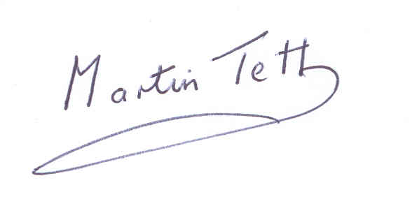  Councillor Martin Tett  Chair - Environment, Economy, Housing & Transport Board, LGA  MCTetts@buckscc.gov.uk  www.local.gov.uk | 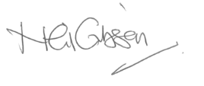  Neil Gibson  ADEPT President 2018/19  negibson@buckscc.gov.uk  www.adeptnet.org.uk

Postal address for both Cllr Tett and Neil Gibson: Buckinghamshire County Council, County Hall, Walton Street, Aylesbury, Bucks, HP20 1UA

cc. The Rt Hon David Rutley MP, Parliamentary Under Secretary of State for the Environment

