ADEPT President’s Awards

Deploying Digital Innovation and Technology

Arle Court Park & Ride, Cheltenham

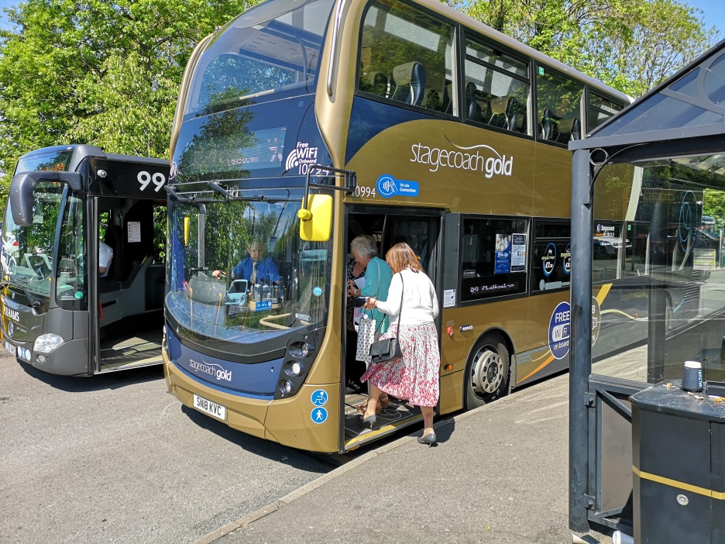

Summary
Gloucestershire County Council (GCC) has applied an innovative digital solution to solve a problem facing many park and rides. By integrating parking and on-bus systems it has transformed customers’ experiences and reinvigorated a service to benefit the local economy.

Context
Arle Court is a 576 space Park & Ride owned by GCC in west Cheltenham, near the M5. Since 2010 it has operated subsidy-free and in 2017 a hospital link was added. Last year DEFRA issued an air quality directive which Euro VI buses are helping to address.
Looking ahead, GCC has £22m LEP Growth Deal funding for West Cheltenham Cyber Park. Arle Court is key to enabling growth whilst managing congestion and improving air quality.
Recently, urban expansion has seen ‘park and walkers’ taking advantage of free parking. By 9.30am, when town centre shoppers arrived, there were no spaces. GCC came under increasing pressure as complaints rolled in, knowing that the commercial bus service would be at risk if a solution wasn’t found.

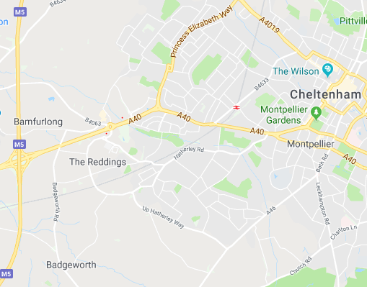
Arle Court

Our system requirements:
- supports commercial bus growth
- Park & Riders park for free
- Park & Walkers pay
- Simple and digital (oxymoron?)
- Flexibility to vary P&W quantity and tariffs
- low set up and ongoing costs
- enforceable
Options ruled out:
- camera enforcement – not lawful
- everyone pays to park – prohibitive for P&R users; VAT charges.
- exit barriers - loss of spaces, costs, queues.
- Park & Ride only – displacement into residential areas
- Machines with P&R and P&W tariffs - cheatable.

Lightbulb Moment
Seeing Bilboa airport bus users validate a prepaid QR ticket using an on-bus scanner….
If a QR ticket could link Park & Riders to their vehicles, in real time, and Park & Walkers paid by phone then CEOs could link every vehicle with a rider, walker or freeloader.
As the Bilboa system worked off-line and market engagement found no solutions GCC commissioned Atkins to develop an innovative digital system with Chipside, Flowbird, Stagecoach, Pulhams Coaches and APCOA.

The Solution
The outcome of this public/private collaboration is a digital solution delivered for under £80,000 and the first time a parking back office system has interfaced with on-bus validation.
Park & Ride customers enter their vehicle registration at the bus stop and receive a reusable QR ticket

.
After boarding and paying the driver they scan the QR ticket at a tablet to confirm their free parking.
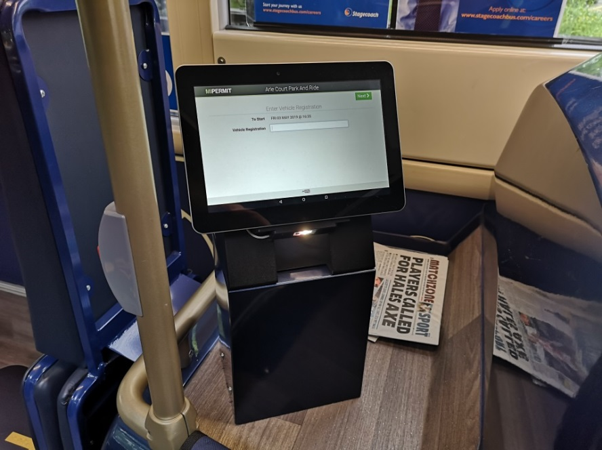
Park and Walkers pay to park using Chipside’s MiPermit digital solution, currently capped at 150 spaces to ensure capacity for bus users.
The bus validation and MiPermit systems communicate in real time with GCC’s parking enforcement system. The car park TRO was rewritten to enable CEO’s to issue a PCN to a vehicle not on a handheld list of validated QR tickets or MiPermit customers.
Following extensive media coverage the system went live in May, proving a hit with shoppers returning to Cheltenham. The site is now 55% full, averaging 230 bus users and 94 “parkers” a day, so promotions being arranged to fill the remaining spaces with bus users.
For more information please contact Philip Williams philip.williams@gloucestershire.gov.uk.

