Deploying Digital Innovation and Technology

Summary
Norfolk County Council have been trialling the use of LoRaWAN technology and low cost road sensors to help avoid unnecessary gritting and save money.
Norfolk County Council, like most local authorities, recognise the need to transform the way we work to meet changing demands and deliver affordable services. Our Highways teams have looked to do this by exploring how the Internet of Things (IOT) can help inform risk and our service priorities. One way we did this is by embarking on a project with our IMT colleagues to trial the use of low-cost sensors to report on road surface temperature, air temperature and humidity.
The project, which was also trialling the use of Long Range Wide Area Network (LoRaWAN) technology, was successfully deployed in an urbanised coastal town to help identify if savings could be made by using the data to reduce the amount of winter gritting runs required in local areas.
The Project
Norfolk, like many rural counties with similar geography, is faced with a few challenges when it comes to data connectivity. Mobile data reception can be patchy and broadband availability can vary. The council’s Digital innovation and Efficiency Committee was established to help improve electronic communications infrastructure across the county. As part of this focus our colleagues in Information Management Technology (IMT) looked to see how we could utilise new LoRaWAN technology as a low-cost mechanism of collecting and retrieving data for a variety of services.
For the Highways service, this provided a unique opportunity for the delivery of our winter service. Winter maintenance costs approximately £3.2 million per year. A single gritting run of all our gritting routes around the county costs around £23,000, so any opportunity to reduce this is always welcome.
At present, a decision to grit our priority routes is made based upon weather forecasting stations based around the county. We have been able to make savings in the past by recognising that some parts of the county are warmer than others and the roads do not need to be treated. However, the opportunity to use low cost sensors to focus in on microclimates of a localised area can help us be more informed and ultimately save money. There would also be environmental benefits of spreading less salt and consuming less fuel.
Our Highways and IMT teams therefore embarked on a project to trial the use of the IOT sensors in Great Yarmouth, Norfolk. Six sensors were deployed across a 10km area, all feeding data across an independent long range wireless network (LoRaWAN) to a single antenna. No air time costs are required and the sensors are powered by a single AA battery with a 2-year life. The data retrieved by the devices are displayed on a website dashboard in real-time and can also be seen in time graphs.
The trial was deemed to be very successful. The sensors were the first to be up and running and is helping pave the way for further development in highways and across the council. As a result, our IMT team have successfully won funding from our Local Enterprise Partnership to build the UK’s largest LoRaWAN network in collaboration with Suffolk County Council over the next two years. This technology is not just isolated to local government either. It is being made available for all local businesses and personal use also.
The success of this trial has been helped by the strategic vision to embrace new technologies and collaboration between a variety of teams, including local district and borough councils who have also been kept up to date with the project.
The future investment in LoRaWAN technology undoubtedly opens up new opportunities for our highways service and numerous other services across the council as evidenced by the success of this project. Further deployments are planned in other large Norfolk towns this summer to see if similar efficiency saving can be realised in other urban areas.

Pictures of the Sensors being installed in Great Yarmouth, Norfolk:
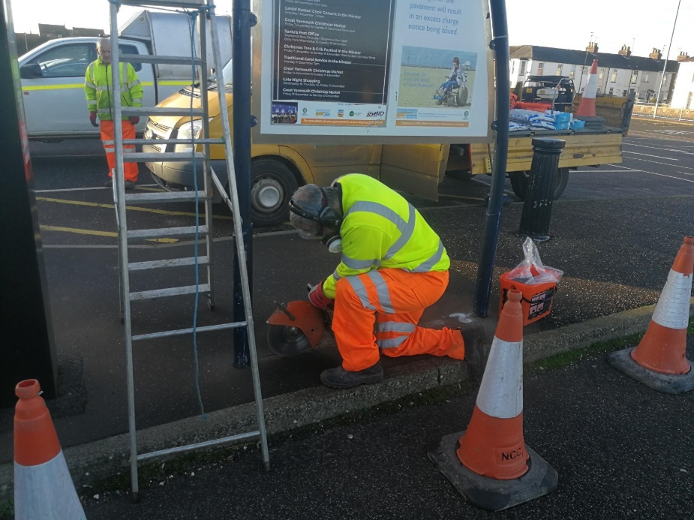

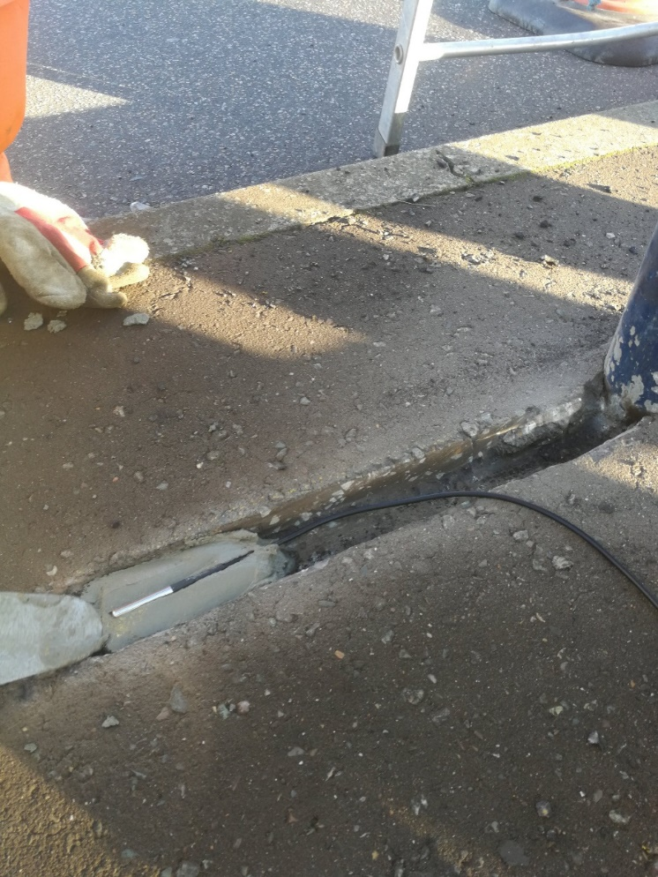
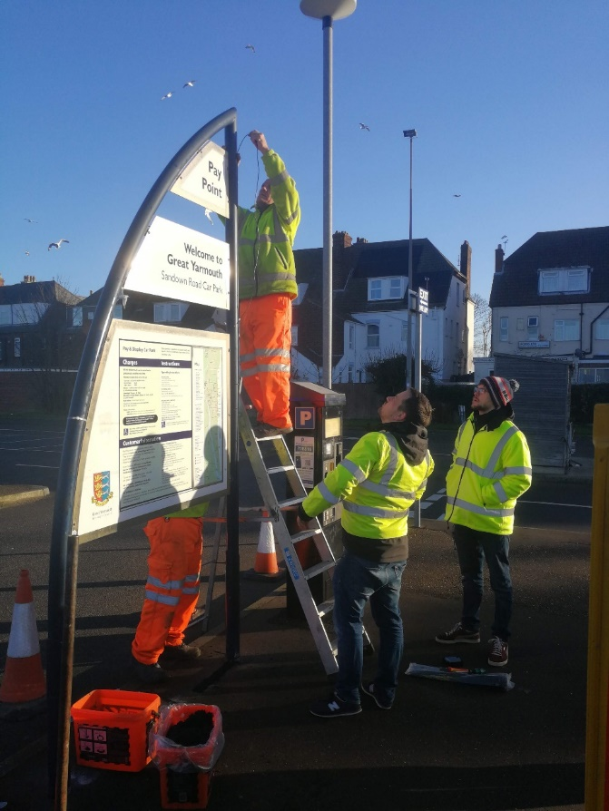

Example of sensor readings:
