ADEPT President's Awards 2019

Category 2 – Deploying Digital Innovation & Technology

Project Name: COACH – Connecting Older Adults to Care & Health
Organisation: Oxfordshire County Council - Innovation Team
Contact: DeeDee Wallace, Health & Care Innovation Lead Deirdre.wallace@oxfordshire.gov.uk 07909882913

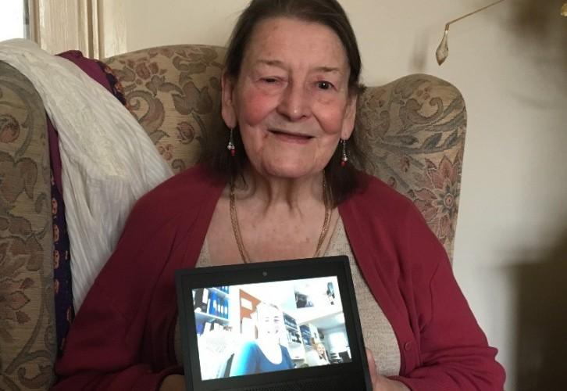

Connecting Older People to Care & Health through voice enabled technology

Connecting Older Adults to Care and Health (COACH) was a pilot project delivered by Oxfordshire County Council’s Innovation Team assessing how audio-visual connective technology could enhance the quality of life for older people 65+ living independently at home and requiring ongoing social care support.

Ten older people participating in the project were provided with Amazon Echo Show devices and received training in using Alexa voice-controlled skills such as video calling with carers, friends and family, setting reminders for medication prompting, making shopping lists, listening to audiobooks, music and news programmes, and telling the time.

The COACH project identified leading indicators that introduction of connected voice-command technology has the potential to improve health and wellbeing through improved connectivity and digital skills, increase efficiency of care delivery without impact on quality of service and ultimately facilitate those currently receiving home care to be able to remain in their homes for longer.

The project further identified several key groups for whom the introduction of this technology may be particularly beneficial, particularly individuals who are visually impaired and housebound, and individuals wishing to consume media in languages other than English.

80% of the project participants reported they felt less isolated and better supported to maintain their independence by having access to device and functionality.

All participants reported that use of Alexa improved their mood, health & wellbeing as well as stating that they would recommend use of the device to older people like themselves receiving support at home.

Two individuals have reduced their care packages as a direct result of using the technology - representing efficiency savings for the local authority in social care costs.

There was a 20% improvement in reported social isolation over the course of the project, and a 20% improvement in self-reported feelings of anxiety and depression in participants.

As a result of the success of the pilot Adult Social Care Services in Oxfordshire are in the process of rolling this technology out more widely to transform care for older people.

