ADEPT President’s Awards
Entrant: South Gloucestershire Council
Category 2: Deploying Digital Innovation and Technology
Portfolio: Inclusive and Prosperous Economy
Programme: Open to Innovation
Project: Connected & Autonomous Vehicles

Innovative research in Connected & Autonomous Vehicles has enabled the council to plan how residents, visitors and businesses will travel in future
The council’s Open to Innovation Programme commenced in summer 2015 to take advantage of extraordinary local academic and business networks, which we support the facilitation of through our Innovate to Grow Campaign. Since then, we have collaborated on four Innovate UK (IUK) funded Connected & Autonomous Vehicle (CAV) research and development (R&D) projects. Our motivation for doing so was to release the economic benefits CAVs would bring to South Gloucestershire.
Direct benefits that have materialised since our involvement in CAV projects have been the growth of local supply chains, inward investment and securing further IUK CAV funding. More significantly however, an indirect benefit has been securing funding from our Local Enterprise Partnership (LEP) for an open access wireless test network. We were able to utilise insight gained from early CAV projects (focussing on vehicle to infrastructure connectivity) to develop a business case for a 5G network that could support future CAV R&D in an urban real-world environment.
The council co-purchased Bristol and Bath Science Park (BBSP) with University of Bath in summer 2018 and since then we have progressed plans to build new space to accommodate growth of existing tenants and attract inward investment. One way to help achieve this is to provide a compelling proposition to not only entice businesses to locate there but also for them to flourish once here (particularly those involved in CAV R&D). The internet of Things (IoT) digital test bed currently being designed will connect BBSP with University of the West of the England (UWE) Enterprise Zone (EZ) and provide an IoT playground for industry and academia to test and deploy CAV technologies and therefore encourage economic development and growth at BBSP.
As part of our Innovate to Grow Campaign, we have been instrumental in bringing technology companies and university researchers together to facilitate dialogue on how local expertise (of international significance) in robotics, autonomous systems and artificial intelligence can shape the CAV industry. The Digital Thread/Digital Manufacturing capability emerging at BBSP along with continued expansion of the National Composites Centre and the construction of the Institute of Advanced Automotive Propulsion Systems further complement CAV R&D.
The outputs of the council’s involvement in these CAV projects have been realised through completion of two of them, but we are still engaged in a further two (concluding next year). The results of early projects helped us understand how traffic can be managed using ‘city dashboards’, the success of which is dependent on 5G infrastructure (to support vehicle to infrastructure communication). Through supporting real-world CAV demonstrations in the two remaining projects (involving PODs and electric light commercial vans), we will capture learning and reflect this in the regional Future Mobility Zone bid we’re currently applying for. Doing so will ensure the outcome of CAV projects can be transferred directly for resident, visitor and business benefit. This will mean people will travel in a safer, more sustainable and informed manner, catalysing cost saving for the council and for users, thus contributing towards economic prosperity for all.

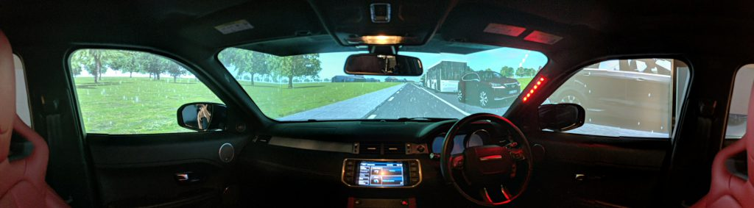
Venturer Project Simulator
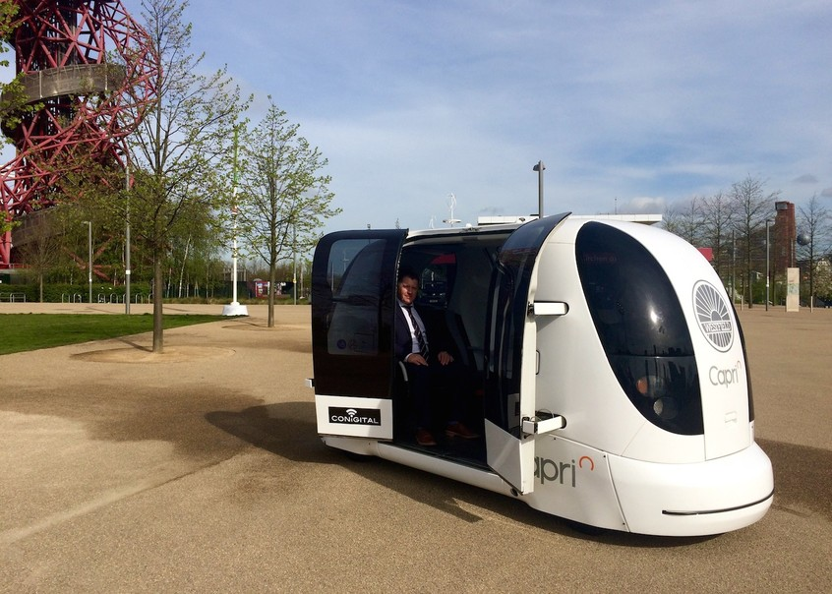
CAPRI POD

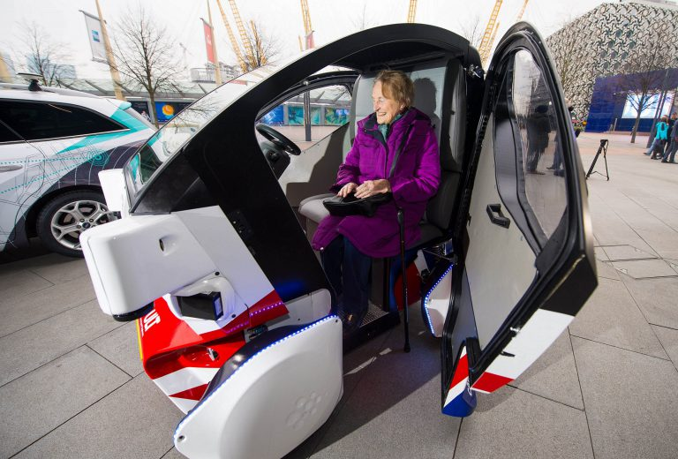
Flourish POD
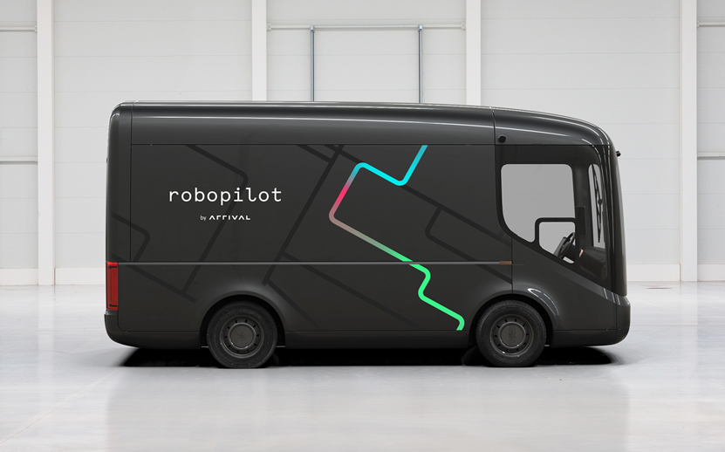
RoboPilot Light Commercial Electric Van

