|  |  |
| --- | --- |
| Our ref:  Your ref:  Chief Engineers, Devolved Administrations | Temple Quay House  2 The Square  Temple Quay  Bristol BS1 6HA  2 March 2018 |

Dear

LIGHTING ASSET FAILURES - PHILIPS LUMA 2/3 AND URBIS-SCHREIDER AMPERA MAXI

I hope your networks are managing well in these challenging weather conditions.

You will have noticed that Highways England has issued a number of safety alerts and CHE memoranda in recent days. I hope you find the information below useful in providing some further background on the issue and our efforts in resolving the potential safety issues.

Highways England has experienced a number of LED luminaire failures from 3 different designs provided by 2 different manufacturers relating to the Philips Luma 2/3 and the Urbis-Schreider Ampera Maxi units.

We have had an isolated case of the clasp holding the canopy down not being properly secured. The result was that the canopy separated from the main body and smashed a windscreen of a passing customer. The safety alert we issued HE-i042 reminds our operatives to be more vigilant and to review whether the gloves they use give the tactile feedback they need.

The second failure is a greater cause for concern. A Philips Luma 2/3 unit fell to ground without causing damage or harm to a third party. Further examination of 200 units nearby identified that over 95% had loose fixing bolts.

We have engaged external specialists to understand the cause and failure mechanism. It appears to be a complex failure mechanism that will take some weeks to fully understand. In the interim I have approved a mitigation measure of placing metal banding around the luminaire and the bracket arm and holding the two together with a stainless steel lanyard. This will cause the luminaire to failsafe. The diagram below explains:

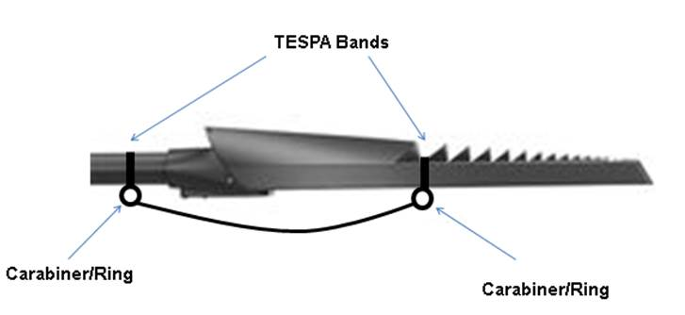

When we have fully developed and tested this design, which we hope to complete in the next two weeks, this will most likely result in another CHE memorandum. In the interim, my specialist is available to discuss progress with you (Stuart Beale 0300 470 4115)

The third design to fail resulted in 3 Urbis Ampera Maxi units falling to ground with sheared fixing bolts. In these cases, the unit failure resulted in units drooping or hanging prior to falling to ground and so we were able to remove Similar to above, the initial investigation identified loose bolts entering a fatigue cycle. We are conducting metallurgy testing to fully understand the failure mode and the cause. We are likely to apply the same lanyard solution to this design as the Philips design.

We have issued Safety Alert HE-i043 in response to this type of failure reminding our operatives to scout for issues and address any lighting heads they feel are compromised through removal if necessary.

While only 4 out of 26,000 LED luminaires have failed, one would be too many, but so many units failing in the first 15% of their lifetime could indicate there may be an underlying issue with manufacturing quality, the mechanical test specification or some other common factor. What our investigations are showing is that sharing of data and knowledge between teams and disciplines is essential to keep things moving at pace. I would invite you to share any similar experiences with my specialists and we can assist with co-ordinating resolution in collaboration with the manufacturers.

We will keep you updated on progress with resolution of the issues.

Yours sincerely



Nicola Debnam, on behalf of Mike Wilson

Chief Highways Engineer, Highways England